# Optimizing Blue-Collar Job Opportunities: A Web-Based Solution for Youth Employment in Kenya

**Andrew Okombo 145454**

# Mark Kipchumba 135881

**Submitted in partial fulfillment of the requirements of the Bachelor of Business and Information Technology at Strathmore University**

# School of Computing and Engineering Sciences Strathmore University

**Nairobi, Kenya**

# May 2023

# Declaration and Approval

We declare that this work has not been previously submitted and approved for the award of a degree by this or any other University. To the best of our knowledge and belief, the research proposal contains no material previously published or written by another person except where due reference is made in the research proposal itself.

Student Name: Andrew Okombo Admission Number: 145454

Student Signature: Date:

Student Name: Mark Kipchumba Admission Number: 135881

Student Signature: Date:

Supervisor Name: Daniel Machanje

Supervisor Signature: Date:

# Abstract

Youth unemployment in Kenya has been a persistent problem not only in Kenya but around the world. The high unemployment rate has significant social and economic consequences, including poverty, social unrest and reduced economic growth. With its constant rise, youth unemployment has become a global concern in the 21st century. In fact, platforms such as LinkedIn, Indeed and Glassdoor provide job postings with concise and comprehensive systems. However, they only provide opportunities to white-collar jobs. This project proposes a web- based system that effectively addresses the problem of youth unemployment in Kenya by recommending job opportunities to blue-collar jobseekers based on their skill set.

# Table of contents

Declaration and Approval II

Abstract III

Table of Figures VI

Chapter 1 Introduction 6

* 1. Background information 1
  2. Problem Statement 2
  3. General Objective 2
  4. Specific Objectives 2
  5. Research Questions 3
  6. Justification 3
  7. Scope 3

Chapter 2 Literature Review 5

* 1. Introduction 5
  2. The Job Market in Kenya 5
  3. Challenges faced by Youth in Job Unemployment 6
  4. Review of Existing Systems 7
     1. Indeed 7
     2. LinkedIn 7
     3. Glassdoor 8
  5. Gaps in Existing Systems 9
  6. Conceptual Framework 9
     1. Job Seekers 10
     2. Employers 10
     3. Administrators 10

Chapter 3 Development Methodology 11

* 1. Introduction 11
  2. Software Development Methodology 11
     1. Product Backlog 12
     2. Sprint 12
     3. Sprint Backlog 12
  3. System Analysis 13
     1. Functional Requirements 13
     2. Non-functional Requirements 13
     3. System Development Tools 13
  4. Deliverables 14
     1. Use Case Diagram 14
     2. System Proposal 14

References 28

# Table of Figures

Figure 3.1 Scrum Methodology (Amazon, 2023; KnowledgeHut, 2023) 13

Figure 4.2 Sequence Diagram 21

Figure 4.3 UML 21

Figure 4.4 ERD 22

Figure 4. 5 Database Schema 23

Figure 4.6 Sequence Diagram 25

Figure 7 System Architecture 31

Figure 8.2 Login page HTML 34

# Chapter 1 Introduction

# Background information

In Kenya, the youth unemployment rate is estimated at 7.4% and is highest among youth aged between 15 and 19 years and 20 and 24 years according to a report by UNICEF (United Nations, 2022) . The high unemployment rate has significant social and economic consequences, including poverty, social unrest, and reduced economic growth. Various stakeholders such as the Kenyan government, international organizations, and civil society have confirmed youth unemployment as a significant problem that requires attention. According to Raphael Obonyo, the Youth Congress director and founder states that this is a persistent problem that needs to be addressed if significant opportunity for young people is to be realized today.

Young people are the primary victims of youth unemployment in Kenya. Raphael Obonyo continues to state that seven of every ten unemployed Kenyans are aged between thirty-five and below (Muchiri, 2022) . However, the consequences of this problem are not limited to young people but extend to institutions, businesses, and the overall economy.

Several researchers, academicians, and experts in the field have researched youth unemployment and proposed various solutions. Efforts to address the problem have included providing education and training opportunities. This resonates with an article in the Business Daily where, The National Employment Policy has been developed to address rising youth unemployment, which has been blamed for insecurity, disillusionment, and radicalization among young Kenyans (Daily, 2014) . While some progress has been made, the problem persists, and significant gaps remain.

To address this problem, the government has invested billions of shillings in programs and training to support the youth in the past years. These include initiatives like Kazi Kwa Vijana, Youth Enterprise Development Fund, and the revamped National Youth Service. To better the situation and solve the problem of youth unemployment, a system that incorporates various stakeholders and solutions is needed. This system will focus on improving access to job opportunities and addressing the skills gap between the labor market demands and skills possessed by young people.

Without appropriate measures, the consequences of youth unemployment in the blue- collar sector can include diminished economic growth, social inequality, and reduced

prospects for individual and national development. By leveraging web technology and implementing tailored strategies, it is possible to enhance access to blue-collar employment for young individuals, thereby promoting their socioeconomic well-being and fostering a more inclusive and thriving workforce.

# Problem Statement

Unemployment, particularly among young people, is a challenge around the world (Generation, 2023). The unemployment rate among young people in Kenya stood at 16.3 percent in 2021 according to Statista Group. With its constant rise, youth unemployment has become a global concern in the 21st century. When a person remains unemployed for a long period, they tend to live a destructive life (Independent press, 2019). According to a report by Urban Institute, being out of work for six months or more is associated with lower well-being among the long-term unemployed, their families, and their communities.

Despite the Kenyan government's efforts to create employment opportunities, there is a need for a web system that seeks to address youth unemployment. Additionally, employers seeking skilled blue-collar workers often struggle to connect with qualified candidates efficiently. Therefore, there is a need to develop a web-based system that effectively bridges the gap between job seekers and employers in the blue-collar sector.

# General Objective

To create a web-based system that effectively addresses the problem of youth unemployment in Kenya by recommending job opportunities based on their skill set and qualifications.

# Specific Objectives

* + 1. To investigate existing systems that provide job opportunities for people to access.
    2. To establish the challenges experienced by young people in accessing. blue-collar job opportunities.
    3. To design a web-based system that can place job opportunities for unemployed youth.
    4. To develop the web-based system incorporating various components such as job search and matching algorithms based on their skills.
    5. To test the developed system and evaluate its effectiveness in placing job.

opportunities.

# Research Questions

* + 1. What are some of the existing systems that provide job opportunities in Kenya?
    2. What are the main challenges experienced by young people in accessing blue- collar job opportunities and how have previous systems addressed these challenges?
    3. How will a website system that enhances job opportunities in Kenya be designed?
    4. How will the website system be developed to incorporate various components such as job search and matching algorithms?
    5. How will the website system enhance job opportunities in Kenya be tested?

# Justification

Youth unemployment is a significant problem in Kenya that has far-reaching. consequences for the social and economic development of the country. The proposed research seeks to create a web system that can provide a sustainable solution to this problem by enhancing job opportunities through a web system.

The research is justified by the need to contribute to the reduction of youth unemployment in Kenya, which will not only improve the economic and social well- being of young people but also promote national development.

Additionally, the proposed research will provide valuable insights into the underlying causes and challenges of youth unemployment in Kenya, as well as the effectiveness of previous interventions aimed at addressing the problem.

This research will benefit various stakeholders, including young people, government agencies, non-governmental organizations, and private sector players, among others. Young people will benefit by accessing job opportunities that will enhance their employability and income-generating potential. Government agencies and non- governmental organizations will benefit from evidence-based insights that can inform policy making and intervention design. Private sector players will benefit from a more skilled and productive workforce, as well as a larger pool of potential customers with increased purchasing power.

# Scope

The scope of the proposed research will be limited to young people aged between 18 and 35 years, who are the most affected by the problem of youth unemployment in

Kenya. The system is not to act as a replacement for current job-seeking websites but to integrate blue-collar jobs.

The stakeholders involved in the research will include young people, government agencies, non-governmental organizations, and private sector players among others. The research will make use of various tools and techniques that include surveys interviews and system development methodologies.

The job seekers are limited to only blue-collar jobs such as artisans, plumbers, technicians, etc. The platform will enable a user to connect with potential clients based on their skillset, location, and experience.

# Chapter 2 Literature Review

# Introduction

This Chapter addresses the various problems faced by the unemployed youth and reviews the various existing job-seeking platforms.

# The Job Market in Kenya

The job market within Kenya is very diverse and encompasses various sectors of industries. The job market in Kenya is dynamic and diverse, it encompasses various sectors and industries. Kenya has a mixed economy with agriculture being the leading, manufacturing, services, and technology sectors playing significant roles in employment and economic growth (Economic, 2023).

Business processes play a crucial role in shaping employment opportunities and determining the dynamics of the job market. Companies in Kenya typically follow established recruitment and selection procedures to identify and hire suitable candidates for their job vacancies (Corporate staffing, 2019) . These processes often involve advertising job openings, conducting interviews and assessments and making final hiring decisions based on qualifications and experience.

However, there can be a disparity between the expectations of job seekers and the reality of the job market. Job seekers may have high expectations regarding salary, benefits, and career progression while the job market may not always meet these expectations due to factors such as limited job openings, competition, and market conditions. The job market in Kenya is highly competitive and individuals often need to possess relevant skills, qualifications, and experience to secure desired positions.

A significant portion of the job market in Kenya operates in the informal sector which includes small businesses, self-employment, and casual labor. This sector provides livelihoods for a substantial number of people, but it often lacks job security, social benefits, and decent working conditions. According to Jacqueline Mugo an Executive Director at Federation of Kenya Employers, she states that Kenya has a large informal economy that makes significant contribution to employment creation, income generation, poverty reduction and economic growth.

There exists a gap between the skills demanded by employers and those possessed by job

seekers. The rapid advancement of technology and evolving market needs require individuals to have relevant and up-to-date skills. The lack of technical and vocational training opportunities contributes to this gap.

This section examines the business processes that support the specific blue-collar jobs that our initiative seeks to address. This project aims to build a website that will act as a platform for those who want to work in blue-collar occupations but may not have the necessary technical training or educational background.

# Challenges faced by Youth in Job Unemployment

Gender inequality exists in the job market, with women facing challenges such as limited access to education, cultural biases, and education. This challenge leads to shortage of skilled workers and increased cost of business due to need to outsource or retain employees. Not solving this challenge would perpetuate inequality and limit economic mobility for those interested in pursuing blue collar careers.

Various initiatives have been implemented to address this challenge, such as the promotion of apprenticeships and vocational training programs, the creation of job boards and websites that cater specifically to blue-collar jobs, and the development of public-private partnerships to promote awareness and access to blue-collar career opportunities.

However, there are still gaps in the ecosystem, including the lack of diversity and inclusion in the blue-collar workforce and the need for more targeted outreach and marketing to change the perception of blue-collar jobs. The project aims to contribute to addressing these gaps and creating a more inclusive and accessible ecosystem for blue- collar jobs. The next chapter will detail the methodology used to conduct research and develop the platform to address the challenges identified in this chapter.

Various initiatives have been implemented to address this challenge, such as the promotion of apprenticeships and vocational training programs, the creation of job boards and websites that cater specifically to blue-collar jobs, and the development of public-private partnerships to promote awareness and access to blue-collar career opportunities.

However, there are still gaps in the ecosystem, including the lack of diversity and inclusion in the blue-collar workforce and the need for more targeted outreach and marketing to change the perception of blue-collar jobs. The project aims to contribute to

addressing these gaps and creating a more inclusive and accessible ecosystem for blue- collar jobs. The next chapter will detail the methodology used to conduct research and develop the platform to address the challenges identified in this chapter.

# Review of Existing Systems

There are a few systems in place that have tried to solve this problem either within Kenya or in other countries. This section gives a brief explanation of how they operate.

# Indeed

Users of the well-known job search engine indeed can look for job openings by area and keyword. The platform allows users to apply for white-collar jobs directly through the website and utilizes an algorithm to match job searchers with appropriate job posts. Ruby on Rails, MySQL, and other tools and technologies were used in the development of Indeed (Indeed, Youtube, 2020) . The problem of limited access to job posts and the time-consuming procedure of looking for opportunities across several platforms is resolved by Indeed.

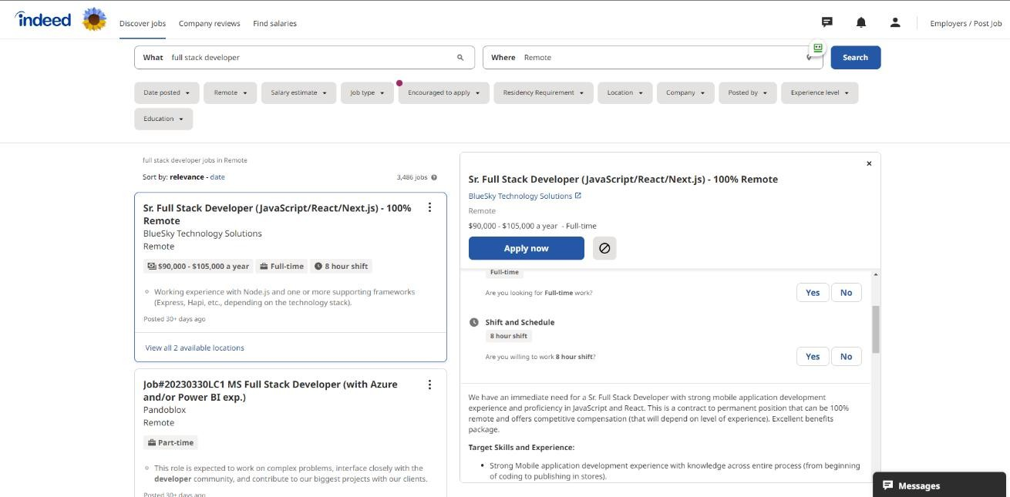

Figure 2.1 Indeed Homepage (Indeed,2023)

# LinkedIn

LinkedIn: a professional networking site that can construct a profile that highlights their education, employment experience, and talents. The online platform also enables users to look for mostly white-collar job opportunities and network with other industry experts. Java, the Spring Framework, and the Oracle Database were among the tools and technologies used in the development of LinkedIn. By offering a forum for users to demonstrate their abilities and connect with other professionals and employment prospects, LinkedIn addresses the issues of limited access to professional networks and

the lack of visibility for job seekers. (LinkedIn, 2023)

Figure 2.2 LinkedIn Homepage

# Glassdoor

Job searchers can get employer evaluations, salary data, and interview questions from current and past employees on the job search and recruiting website, Glassdoor. Additionally, the portal enables users to browse job openings and submit their applications online. Java, AngularJS, and MySQL were among the tools and technologies used in the development of Glassdoor. The problem of limited access to information about businesses and their job openings, as well as the absence of transparency in the recruiting process, is resolved by Glassdoor. (Glassdoor, 2023)

Figure 2.3 Glassdoor Homepage (Glassdoor, 2023)

# 

# Gaps in Existing Systems

The absence of diversity and inclusiveness in the job postings themselves is a significant gap. For instance, many job postings feature hidden biases or utilize gendered terms, which may discourage some groups from applying. As a result, opportunities for minorities may be limited and the workforce may become homogenous.

Lack of individualized guidance and career development tools is another gap. These platforms might give simple keyword- or location-based filtering and matching algorithms, but they frequently fall short of making personalized suggestions based on a user's qualifications, experience, and career objectives. When job seekers must wade through ineffective job postings, this can cause irritation and wasted time.

Additionally, several job search engines have come under criticism for not doing enough to stop fraud and false job ads. For job searchers who unintentionally apply for a fraudulent job or fall for a scam, this might result in wasted time and resources. The techniques and criteria that these platforms use to rank job ads and choose which ones to display to users are not transparent. This may limit possibilities for qualified candidates and give the impression that the hiring process is unfair or biased.

# Conceptual Framework

The proposed web-based solution aims to address the problem of youth unemployment in blue-collar jobs by streamlining the process of job matching and improving access to job opportunities. The solution consists of several components that work together to facilitate input, processing, storage, and output involving various stakeholders.

Figure 2.4 Conceptual Framework

# Job Seekers

Job seekers provide their skills, qualifications, experience, and preferences through user profiles on the web-based platform.

The system processes the input data from job seekers and matches them with relevant job listings based on their profile information and the requirements specified by employers. Job seeker profiles and application records are securely stored in a database for future reference and tracking.

The system generates personalized job recommendations, application status updates and notifications to job seekers helping them navigate the job market effectively.

# Employers

Employers input job vacancies, job descriptions, required qualifications and other relevant details into the web-based platform.

The system processes the employer's input and matches job vacancies with suitable candidates based on their skills, experience, and location.

Employer job listings and company profiles are securely stored in the system's database for reference and future interactions.

The system provides employers with a pool of qualified candidates, facilitates communication with job seekers and generates reports on application status and candidate statistics.

# Administrators

Administrators input and manage the overall functionality and settings of the web-based platform.

They oversee the processing and management of user data, job listings, training resources, and system functionalities.

Administrators ensure the secure storage and maintenance of the platform's database and infrastructure.

They also generate reports and analytics on system usage, user engagement, job market trends, and other relevant metrics to improve the platform's performance and effectiveness.

# Chapter 3 Development Methodology

# Introduction

This chapter highlights the software development methodology and the different aspects of the system analysis and design. The methodology used is Object Oriented Analysis and Design. OOAD involves several techniques and practices, including object-oriented programming, design patterns, UML diagrams, and use cases. Additionally, this section highlights the tools and techniques that will be used in web development and the expected system deliverables.

# Software Development Methodology

The software development methodology refers to the development SDLC (software development life cycle) model, which is focused on organizing beneficial yet effective project development processes from the idea and planning to front-back & back-end development, testing, and software launching. (Intellect Soft, 2022). The system will be developed using the Scrum Methodology. Scrum is an agile development methodology used in the development of Software based on iterative and incremental processes. This is because it is a product of high quality and inspires the team to collaborate.

Figure 3. Scrum Methodology (Amazon, 2023; KnowledgeHut, 2023)

# Product Backlog

A product backlog is a prioritized list of work for the development team that is derived from the roadmap and its requirements. (Radigan, 2020)**.** This step involves identifying a list of all tasks to be completed. These tasks can include updating skill set etc.

# Sprint

A sprint is a short, time-boxed period when a scrum team works to complete a set amount of work. The team exclusively concentrates on the tasks that they had decided to work on during the sprint planning phase. This makes the project better organized and guarantees that tasks are finished on time and within a set amount of time.

# Sprint Backlog

A sprint backlog is a list of work items that need to be completed during a project sprint. This ensures that during each sprint, a task is completed in time and focus is not taken away from that task. The purpose of a sprint backlog is to define work items to tackle within the sprint.

# System Analysis

Requirement Analysis, also known as Requirement Engineering, is the process of defining user expectations for a new software being built or modified.

# Functional Requirements

A jobseeker signs up to the website system. Jobseekers register to the system using email accounts to ensure that all learners are on the system. The website platform aims at benefiting jobseekers to benefit from accessing personalized content depending on their skill set.

A client registers to the platform before uploading available jobs to the online system. A client signs up to the platform through an email account to ensure that the jobs are posted by legitimate individuals.

# Non-functional Requirements

The system responds to a user’s search action within the least amount of time. Therefore, the response time to find and give back a job posting search results based on the job one would want to find is less than or equal to three seconds assuming that the user has a finely and reliable internet connection.

The system assures instant conversations during any chatting scenario. This implies that the collaborative conversations between a client and a job seeker on the platform are to be in real-time and directly accessible on both sides.

# System Development Tools

This is a list of the tools to be used for the development of the system.

# HTML

This is a standard markup language for documents used to display data on a web browser. It is one of the main building blocks of the internet and will be used to develop the website.

# CSS

This is a style sheet language used together with a markup language, such as HTML, to describe the presentation of the document such as color of text and animations thus adding character to a web application.

# Database

It is responsible for storing all the user data for future referencing.

# Deliverables

The deliverables address the specific needs of blue-collar job seekers to facilitate job matching and ultimately improve their employability and access to job opportunities. Job Listing and Matching: The system delivers a user-friendly interface where employers list blue-collar job vacancies and job seekers can easily search and apply for relevant positions. It also provides a robust matching algorithm that connects job seekers with suitable blue-collar job opportunities based on their skills, experience and location.

Employer Verification and Reviews: The system incorporates features to verify and validate employers and their job listings to ensure authenticity and protect job seekers from potential scams. It also allows job seekers to provide feedback and reviews about their experiences with specific employers, fostering transparency and accountability.

Geolocation and Mapping Services: The system includes geolocation and mapping functionalities to help job seekers locate nearby job opportunities. It can display job listings on an interactive map allowing users to explore available blue-collar jobs in their desired locations.

User Support and Assistance: The system offers user support mechanisms such as FAQs, chat support, or helpline services to address any queries or issues faced by job seekers or employers. This provides a timely and effective assistance to ensure a positive user experience.

# Use Case Diagram

A use case diagram is a graphical representation that determines the scope of a system by depicting the functionalities that the system will provide and the users that will interact with it through these functionalities.

# System Proposal

A project proposal document of the personalized job seeking platform shall be provided to define, discuss, and describe the various aspects of the project to be undertaken.

# Jobseeker Module

A web application system shall be developed to allow job seekers to find and get recommendations of job postings through the web application based on their skill set.

# Employer Module

A web application dashboard should be developed to allow clients to upload job postings as well as engage with blue-collar job seekers.

# Geolocation Module

This module will allow the jobseeker to view the address of job location. It will also allow employers to view the location of blue-collar job applicants.

# Chapter 4 System Analysis and Design

* + 1. **Functional Requirements**

The web-based system for youth employment in blue-collar jobs in Kenya offers functionalities such as job search and matching, profile creation and management for job seekers, employer job listing and management, employer verification and reviews, geolocation and mapping services and user support and assistance. These functionalities work cohesively to connect job seekers with relevant blue-collar job opportunities. For employers, the system streamlines the process of posting job vacancies and finding qualified candidates, creating a platform to bridge the gap between job seekers and employers in the blue-collar sector. This table depicts some of the users functionalities.

|  |  |
| --- | --- |
| **USER TYPE** | **FUNCTIONAL REQUIREMENT** |
| **Job seeker** |  |
| FR1 | Ability to create a user account with personal information |
| FR2 | Capability to browse available job listings |
| FR3 | Option to submit job applications online |
| FR4 | Access to a profile dashboard to track application status |
| **Employer** |  |
| FR1 | Ability to create a user account with company information |
| FR2 | Capability to post job listings with relevant details |
| FR3 | Option to edit or remove job postings |
| FR4 | Access to a dashboard to manage posted job listings |
| FR5 | Ability to search and review applications submitted by users |
| **Website Admin** |  |
| FR1 | Ability to manage user accounts and profiles |
| FR2 | Option to edit or remove job postings as necessary |
| FR3 | Access to analytics and reporting functionalities |

# Non-Functional Requirements

Security has been employed as a non-functional requirement in the development of the web-based solution for youth employment in blue-collar jobs in Kenya. Non-functional requirements are those aspects of a system that specify its characteristics, constraints, and qualities, rather than specific functionalities or features. In this context, security is vital to ensure the protection of sensitive data, maintain user privacy, prevent unauthorized access and safeguard the overall integrity of the system.

Security measures have been integrated into the web-based solution to meet this non- functional requirement:

* Data Encryption: To protect sensitive information, data encryption techniques are applied to safeguard data while it is transmitted over the internet and stored in the system's databases. This ensures that data remains confidential and cannot be intercepted or tampered with by unauthorized parties.
* Secure Connection: The system utilizes secure communication protocols, such as HTTPS, to establish encrypted connections between the users' web browsers and the server. This helps to prevent man-in-the-middle attacks and ensures data integrity during data transmission.
* Regular Security Updates: The web-based solution undergoes regular security updates to address potential vulnerabilities and patch any security loopholes. Keeping the system up to date with the latest security patches helps to protect it from emerging threats and cyberattacks.
* Secure Development Practices: During the system's development, secure coding practices are followed to minimize the risk of introducing security flaws. Code reviews and security testing are conducted to identify and fix security vulnerabilities early in the development process.
* Monitoring and Logging: The system implements logging and monitoring mechanisms to track user activities and detect any suspicious or unauthorized access attempts. These logs are regularly reviewed to identify potential security incidents and take appropriate actions.

By prioritizing security as a non-functional requirement, the web-based system ensures the trust and confidence of its users. Addressing security concerns proactively helps to create a safe and secure environment for users to interact with the platform, protecting their sensitive data and enhancing the overall user experience.

**Use Case Diagram**

Figure 4.1Use case Diagram

The use case diagram illustrates the interactions and relationships between the employer job-seeker and admin and use cases within the web-based system for youth employment in blue-collar jobs in Kenya.

Figure 4. Sequence Diagram

The sequence diagram visually represents the overall architecture and components of the web-based solution illustrating the interactions between user interfaces, application modules, databases, external integrations and functionalities.

**UML**

Figure 4. UML

The UML diagram of the system provides a visual representation of the web-based solution depicting its structural elements, user interactions and system behavior to

facilitate communication and understanding among stakeholders

The ERD (Entity-Relationship Diagram) of the system illustrates the logical structure and relationships between entities, attributes, and their cardinality within the web-based solution providing a view of the database organization and facilitating efficient design and management of the system's data.

**ERD**

Figure .4 ERD

**Database Schema**

Figure 4. Database Schema

**Sequence Diagram**

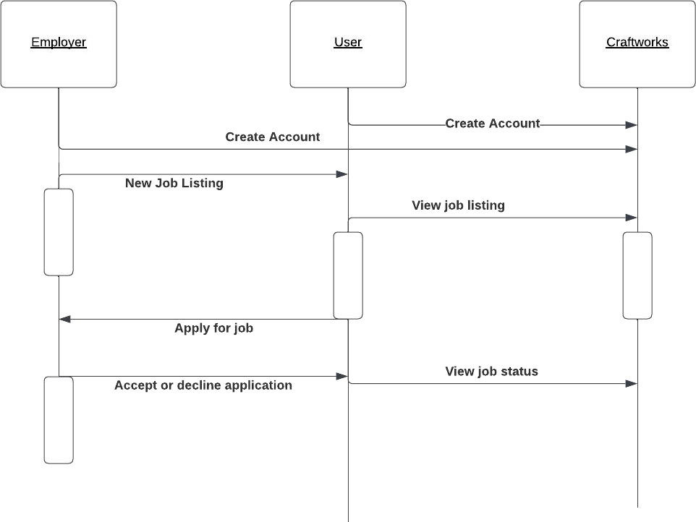

Figure 4. Sequence Diagram

The sequence diagram visually represents the overall architecture and components of the web-based solution illustrating the interactions between user interfaces, application modules, databases, external integrations and functionalities.

**Wireframes**

Figure 11 Wireframe 1

Figure 12 Wireframe 2

Figure 13 Wireframe 3

Figure 14 Wireframe 4

Figure 15 Wireframe 5

Figure 16 Wireframe 6

Figure 17 Wireframe 7

Figure 18 Wireframe 8

Figure 19 Wireframe 9

**System Architecture Diagram**

The interface represents the user-facing components of the system including web pages and mobile applications. Job seekers, employers and administrators interact with the system through this layer to access various functionalities.

The database layer stores and manages the system's data. It includes databases for user profiles, job listings and employer information. The database layer ensures data integrity, security and efficient retrieval and storage of information.

Figure System Architecture

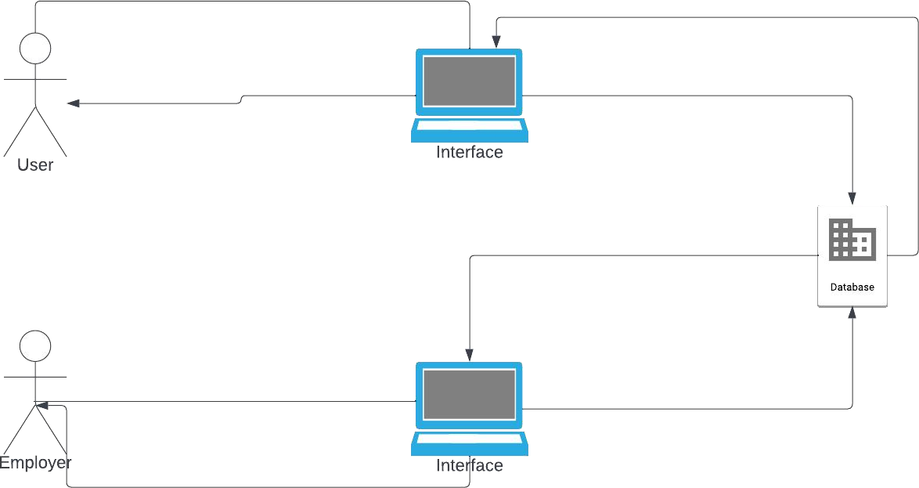

# Chapter 5: System Implementation and Testing

## 5.1 Introduction

This Chapter focuses on the process of creating a website for the Blue-Collar job system.

## 5.1.2 Solution Setup

The programming languages used are CSS, HTML, JavaScript and PHP which were chosen for their specific roles in web development. CSS enhances the front-end development by styling and formatting the user interface, improving the visual appearance. HTML is used to define the structure and content of webpages. While JavaScript help support for dynamic and Interactive Elements which allows form submission handling and content updates without page reload. The project was done by using Visual Studio Code.

## 5.2 Stakeholder Interaction

**For Job seeker**

* Registering and creating a user account
* Searching for job listings
* Submitting job application online
* Tracking the status of their application

For Employer

* Managing and editing job postings.
* Reviewing application submitted by job seekers.
* Interacting with potential employees for further evaluation.
* Registering and creating an employer account.

Website Admin

* Handling user inquiries, feedback, and support requests.
* Editing and removing job postings when necessary.
* Managing user accounts and profiles, including account creation and maintenance

## 5.2.3 Challenges

Some of the various challenges we incurred during the development stage were:

* Technical Complexity: Developing the systems various functionalities and integrations are technically complex and also interacting with Javascript which was new and worth learning.
* Version Control and Deployment: Implementing version control systems, establishing deployment pipelines, and automating deployment processes can help streamline these activities.
* Bug Fixing and Issue Resolution: Identifying the root causes, implementing fixes, and ensuring proper testing and validation before releasing updates can be time-consuming and demanding.

**5.3** **Testing**

|  |  |  |  |
| --- | --- | --- | --- |
| Test Class | Difficulty | Test  Result | Description |
| Functional | Medium | Pass | User Registration |
| Functional | Low | Pass | Job Search and Matching |
| Functional | Medium | Pass | Job Application Submission |
| Functional | High | Pass | Employer Job listing |
| Functional | Medium | Pass | Employer Application Review |
| Non-Functional | Low | Pass | System Security(Website Admin) |

Figure 5.1 Login page

Figure 8.2 Login page HTML

Figure 5.3 Company about HMTL

Figure 5.4 Company About

# References

Amazon. (2023, May 25th). *AWS Management and Governance*. Retrieved from aws.amazom: https://aws.amazon.com

Corporate staffing, S. K. (2019, June 12). *Youtube*. Retrieved from How to get a job in Kenya fast.: https://[www.youtube.com/watch?v=1aj0lIxiRiQ](http://www.youtube.com/watch?v=1aj0lIxiRiQ)

Daily, B. (2014). *Business Daily Africa* . Retrieved from Business Daily Newspaper: https://[www.businessdailyafrica.com/bd/economy/kenya-rolls-out-measures-to-](http://www.businessdailyafrica.com/bd/economy/kenya-rolls-out-measures-to-) tackle-youth-unemployment-2063354.

Economic, A. (2023). Retrieved from An analysis of the economic system in Kenya.: https://[www.economicactivity.org/an-analysis-of-the-economic-system-in-](http://www.economicactivity.org/an-analysis-of-the-economic-system-in-) kenya/#:~:text=The%20economy%20of%20Kenya%20is,and%20investment%20 in%20East%20Africa.

Generation. (2023). *Youth unemployment and its negative health effects.* Retrieved from https://[www.generation.org/news/youth-unemployment-and-its-negative-health-](http://www.generation.org/news/youth-unemployment-and-its-negative-health-) effects/?gclid=CjwKCAjwyeujBhA5EiwA5WD7_XJva3Owph_8rbMx45GxkJQ gIrsUPydFq3Joc4LLFyHYWVL99A6LqhoCzkQQAvD_BwE

Glassdoor. (2023, May 25). *Homepage*. Retrieved from Glassdoor: https://[www.glassdoor.com](http://www.glassdoor.com/)

Indeed. (2020, Jan 8). *Youtube*. Retrieved from 5 Indeed job search tips: https://[www.youtube.com/watch?v=JF0IukoW8to](http://www.youtube.com/watch?v=JF0IukoW8to)

Indeed. (2023, May 25th). *Homepage*. Retrieved from Indeed: https://[www.indeed.com/](http://www.indeed.com/) Independent.press. (2019, June 3). *Youtube*. Retrieved from Youth Unemployment in

Kenya | Clive Lupao on the Impact of Youth Empowerment and Mentorship: https://[www.youtube.com/watch?v=nBPszQN4Dlk](http://www.youtube.com/watch?v=nBPszQN4Dlk)

KnowledgeHut. (2023, April 11). *knowledgeHut.com*. Retrieved from KnowledgeHut: https://[www.knowledgehut.com/blog/agile/product-backlog-refinement-scrum](http://www.knowledgehut.com/blog/agile/product-backlog-refinement-scrum)

LinkedIn. (2023, May 25). *Home page*. Retrieved from LinkedIn: https://[www.linkedin.com](http://www.linkedin.com/)

Muchiri, E. (2022, June 13). *thestar.co.ke*. Retrieved from The Star Newspaper Webpage: https://[www.the-star.co.ke/counties/central/2022-06-13-youth-unemployment-a-](http://www.the-star.co.ke/counties/central/2022-06-13-youth-unemployment-a-) ticking-time-bomb-lobby-warns/

United Nations. (2022). *Draft Country Programme Document.* United Nations.